Workers’ Theatre Movement

The Workers’ Theatre Movement (WTM) was an international project, largely promoted by the Workers International Relief, to conjoin left militant radical theatres during the period of Stalin’s ‘Third Period’ militant class struggle; it was also briefly the name of a workers’ troupe in London. The historical shape of the WTM follows the ideological progress of the Communist International (Comintern), from the hard left turn in 1929 to the collaborative politics of the Popular Front in 1933-34. As proposed by its ideological leaders and principal activists, the Workers’ Theatre Movement was evidence of the transnational emergence of a proletarian culture derived from the universal modernity of industrialism. In practice, the movement was an aggregate of practices and theories drawn into the semblance of an organization through the cultural apparatus of the Comintern.

The Workers’ Theatre Movement was both a loose international alliance and a range of local experiences that varied greatly. In metropolitan centres, the workers’ troupes occupied a gradient ranging from militant street theatres, such as Ewan MacColl’s Red Megaphone in Birmingham, U.K. and the Shock Troupe of the Workers’ Laboratory Theatre in New York, to the radical edges of the professional theatre, such as the Group Theatre in New York and Unity Theatre in London. Outside of major theatrical centres, WTM troupes were more often organized by radical unions, or, as in the case of the Toronto Workers’ Experimental Theatre, by Communist Party cultural clubs.

In its Third Period phase, the workers theatre movement was marked by a struggle expressed in aesthetic debates that were codified in binary oppositions that reflected international factional struggles in the Comintern. In the recurring debates over form which fill the pages of Workers Theatre (renamed New Theatre in 1934), the major question was whether the aesthetics of workers’ theatre were most properly expressed by street and workplace performance (the ‘mobile stage’) or traditional playhouse (‘stationary’) performance; the issue at stake was whether the playhouse stage was an inherently bourgeois institution.

The international retreat from the politically combative agitprop theatre of the WTM, indicative of the pressures leading up to the Popular Front, was announced in December, 1932, at the Second Plenary of the International Union of Revolutionary Theatres in Moscow, which ‘set out tasks’ to correct ‘mistakes and failures.’ The statement focused on the militant sectarianism that agitprop enacted. The statement criticized the ‘serious underestimation of the bourgeois theatre’ and concluded that the ‘vigour and militancy of the agitprop troupes had caused the mistaken view to arise, that such troupes were the only form a revolutionary theater could take. This was left sectarianism which despised other theatrical forms’ (Jones, 132-133).

Although workers’ troupes typically performed agitprops, various organizational structures, including Workers Theatre, sought to establish and circulate a canon of exemplary texts. Of these, the Workers’ Laboratory Theatre’s 1933 play Newsboy (1933) was particularly instrumental in advancing the proposal that the proletarian aesthetics of workers’ theatre, fusing agitprop, choreography, and scenography, was a modernist art that derived its principles from industrialism. At the same time, non-canonical popular culture forms flourished, including Red Vaudeville and workers’ puppet troupes.

By 1935, the WTM had effectively phased out, subsumed in the United States by the Federal Theatre Project and in the UK, Australia, and Canada by Popular Front professionalism that advocated realism, national cultural traditions, and artistry. Many of the Popular Front troupes announced their reformation with productions of Clifford Odets’s Waiting for Lefty (1935), which provided a theatrical bridge from agitprop to realism. The most celebrated of the Popular Front companies was Joan Littlewood’s Theatre Workshop, which was descended from Red Megaphone and had a transformative impact on British theatre after the Second World War.

List of Works

The following collections include workers’ theatre scripts:

Endres, Robin and Richard Wright. (eds.) (1976) Eight Men Speak and Other Plays from the Canadian Workers’ Theatre, Toronto: New Hogtown.

Papa, Lee. (2009) Staged Action: Six Plays from the American Workers' Theater, Ithaca: ILR Press/Cornell University Press.

Samuel, Raphael, Ewan MacColl, and Stuart Cosgrove. (eds.) (1985) Theatres of the Left: 1888-1935; Workers’ Theatre Movements in Britain and America, London: Routledge & Kegan Paul.

References and Further Readings

Cosgrove, Stuart. (1985) “From Shock Troupe to Group Theatre,” Theatres of the Left: 1888-1935; Workers’ Theatre Movements in Britain and America, ed. Raphael Samuel, Ewan MacColl, and Stuart Cosgrove, London: Routledge & Kegan Paul: 259-279.

Filewod, Alan. (1999) ‘“A Qualified Workers Theatre Art”: Waiting for Lefty and the (Re)Formation of Popular Front Theatres,’ Essays in Theatre 17(2) (May): 111-28.

Jones, Leonard. (1964) ‘The British Workers Theatre, 1917-1935,’ PhD diss., Karl-Marx Universitat, Liepzig.

Levine, Ira A. (1985) Left-Wing Dramatic Theory in the American Theatre, Ann Arbor: UMI.

Novikov, Gregory. (1985) Newsboy, Theatres of the Left: 1888-1935; Workers’ Theatre Movements in Britain and America, ed. Raphael Samuel, Ewan MacColl, and Stuart Cosgrove, London: Routledge & Kegan Paul, 316-22.

Saxe, Alfred. (1985) ‘“Newsboy”: From Script to Performance,’ Theatres of the Left: 1888-1935; Workers’ Theatre Movements in Britain and America, ed. Raphael Samuel, Ewan MacColl, and Stuart Cosgrove, London: Routledge & Kegan Paul, 259-279.

Stourac, Richard, and Kathleen McCreery. (1886) Theatre as a Weapon: Worker's Theatre in the Soviet Union, Germany and Britain, 1917-1934, London: Routledge and Kegan Paul.

Alan Filewod, University of Guelph

Recommended Illustrations

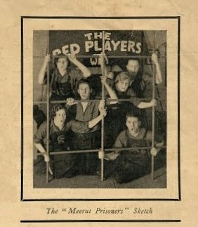

The Red Players, a British workers’ theatre troupe.
[Source: Working Class Movement Library, available online at:
http://www.wcml.org.uk/contents/international/india/meerut--the-workers-theatre-movement-play/ ]

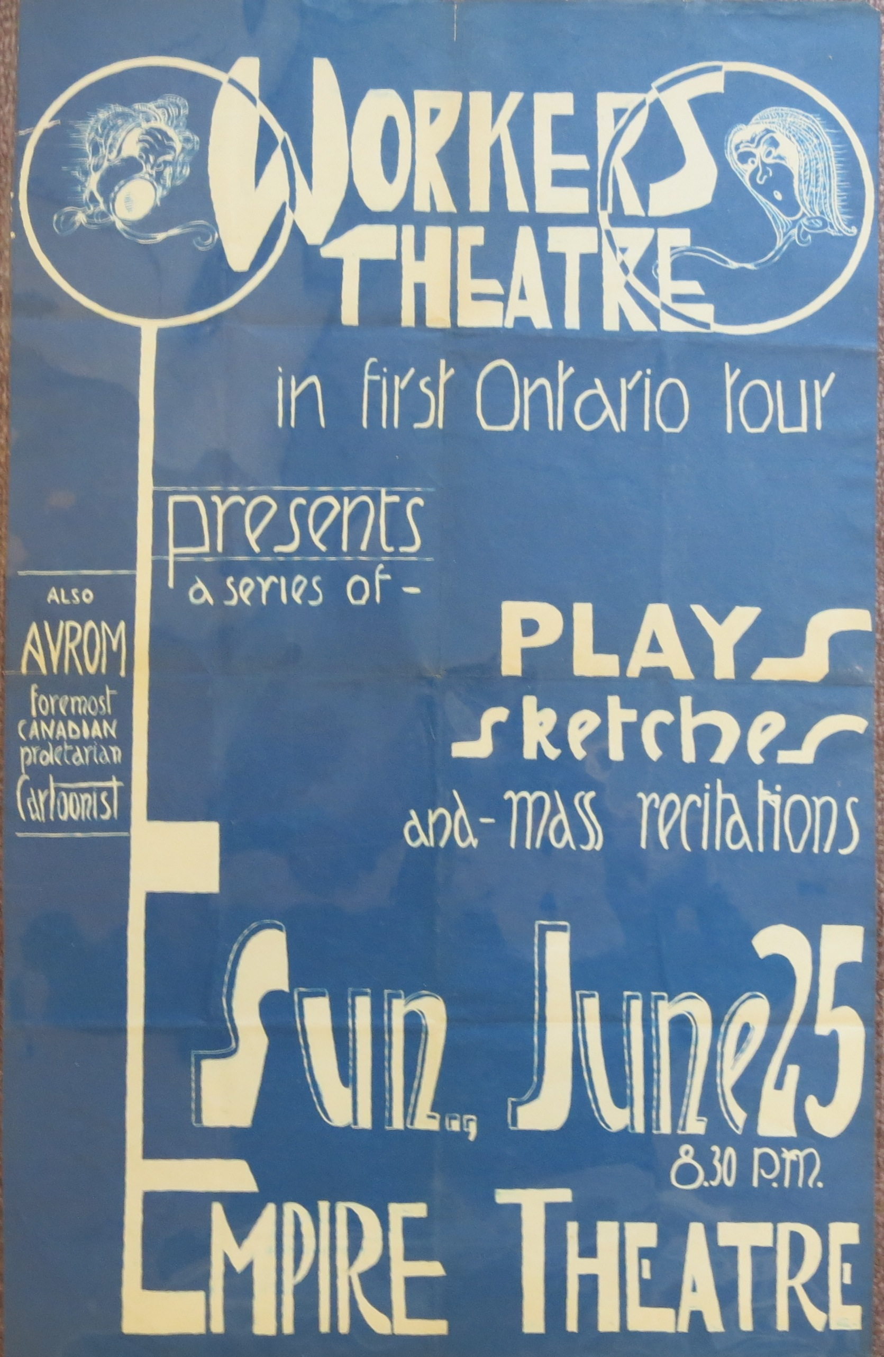
A Workers’ Theatre (Toronto) poster, 1932.
[Source: L.W. Conolly Theatre Archives, McLaughlin Library, University of Guelph

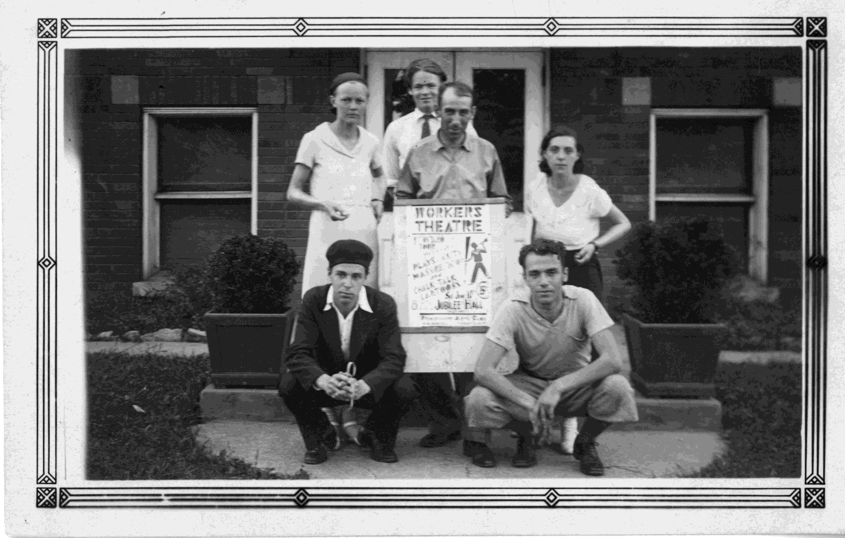
Members of the Toronto Workers’ Theatre, 1932.
[Source: L.W. Conolly Theatre Archives, McLaughlin Library, University of Guelph.]

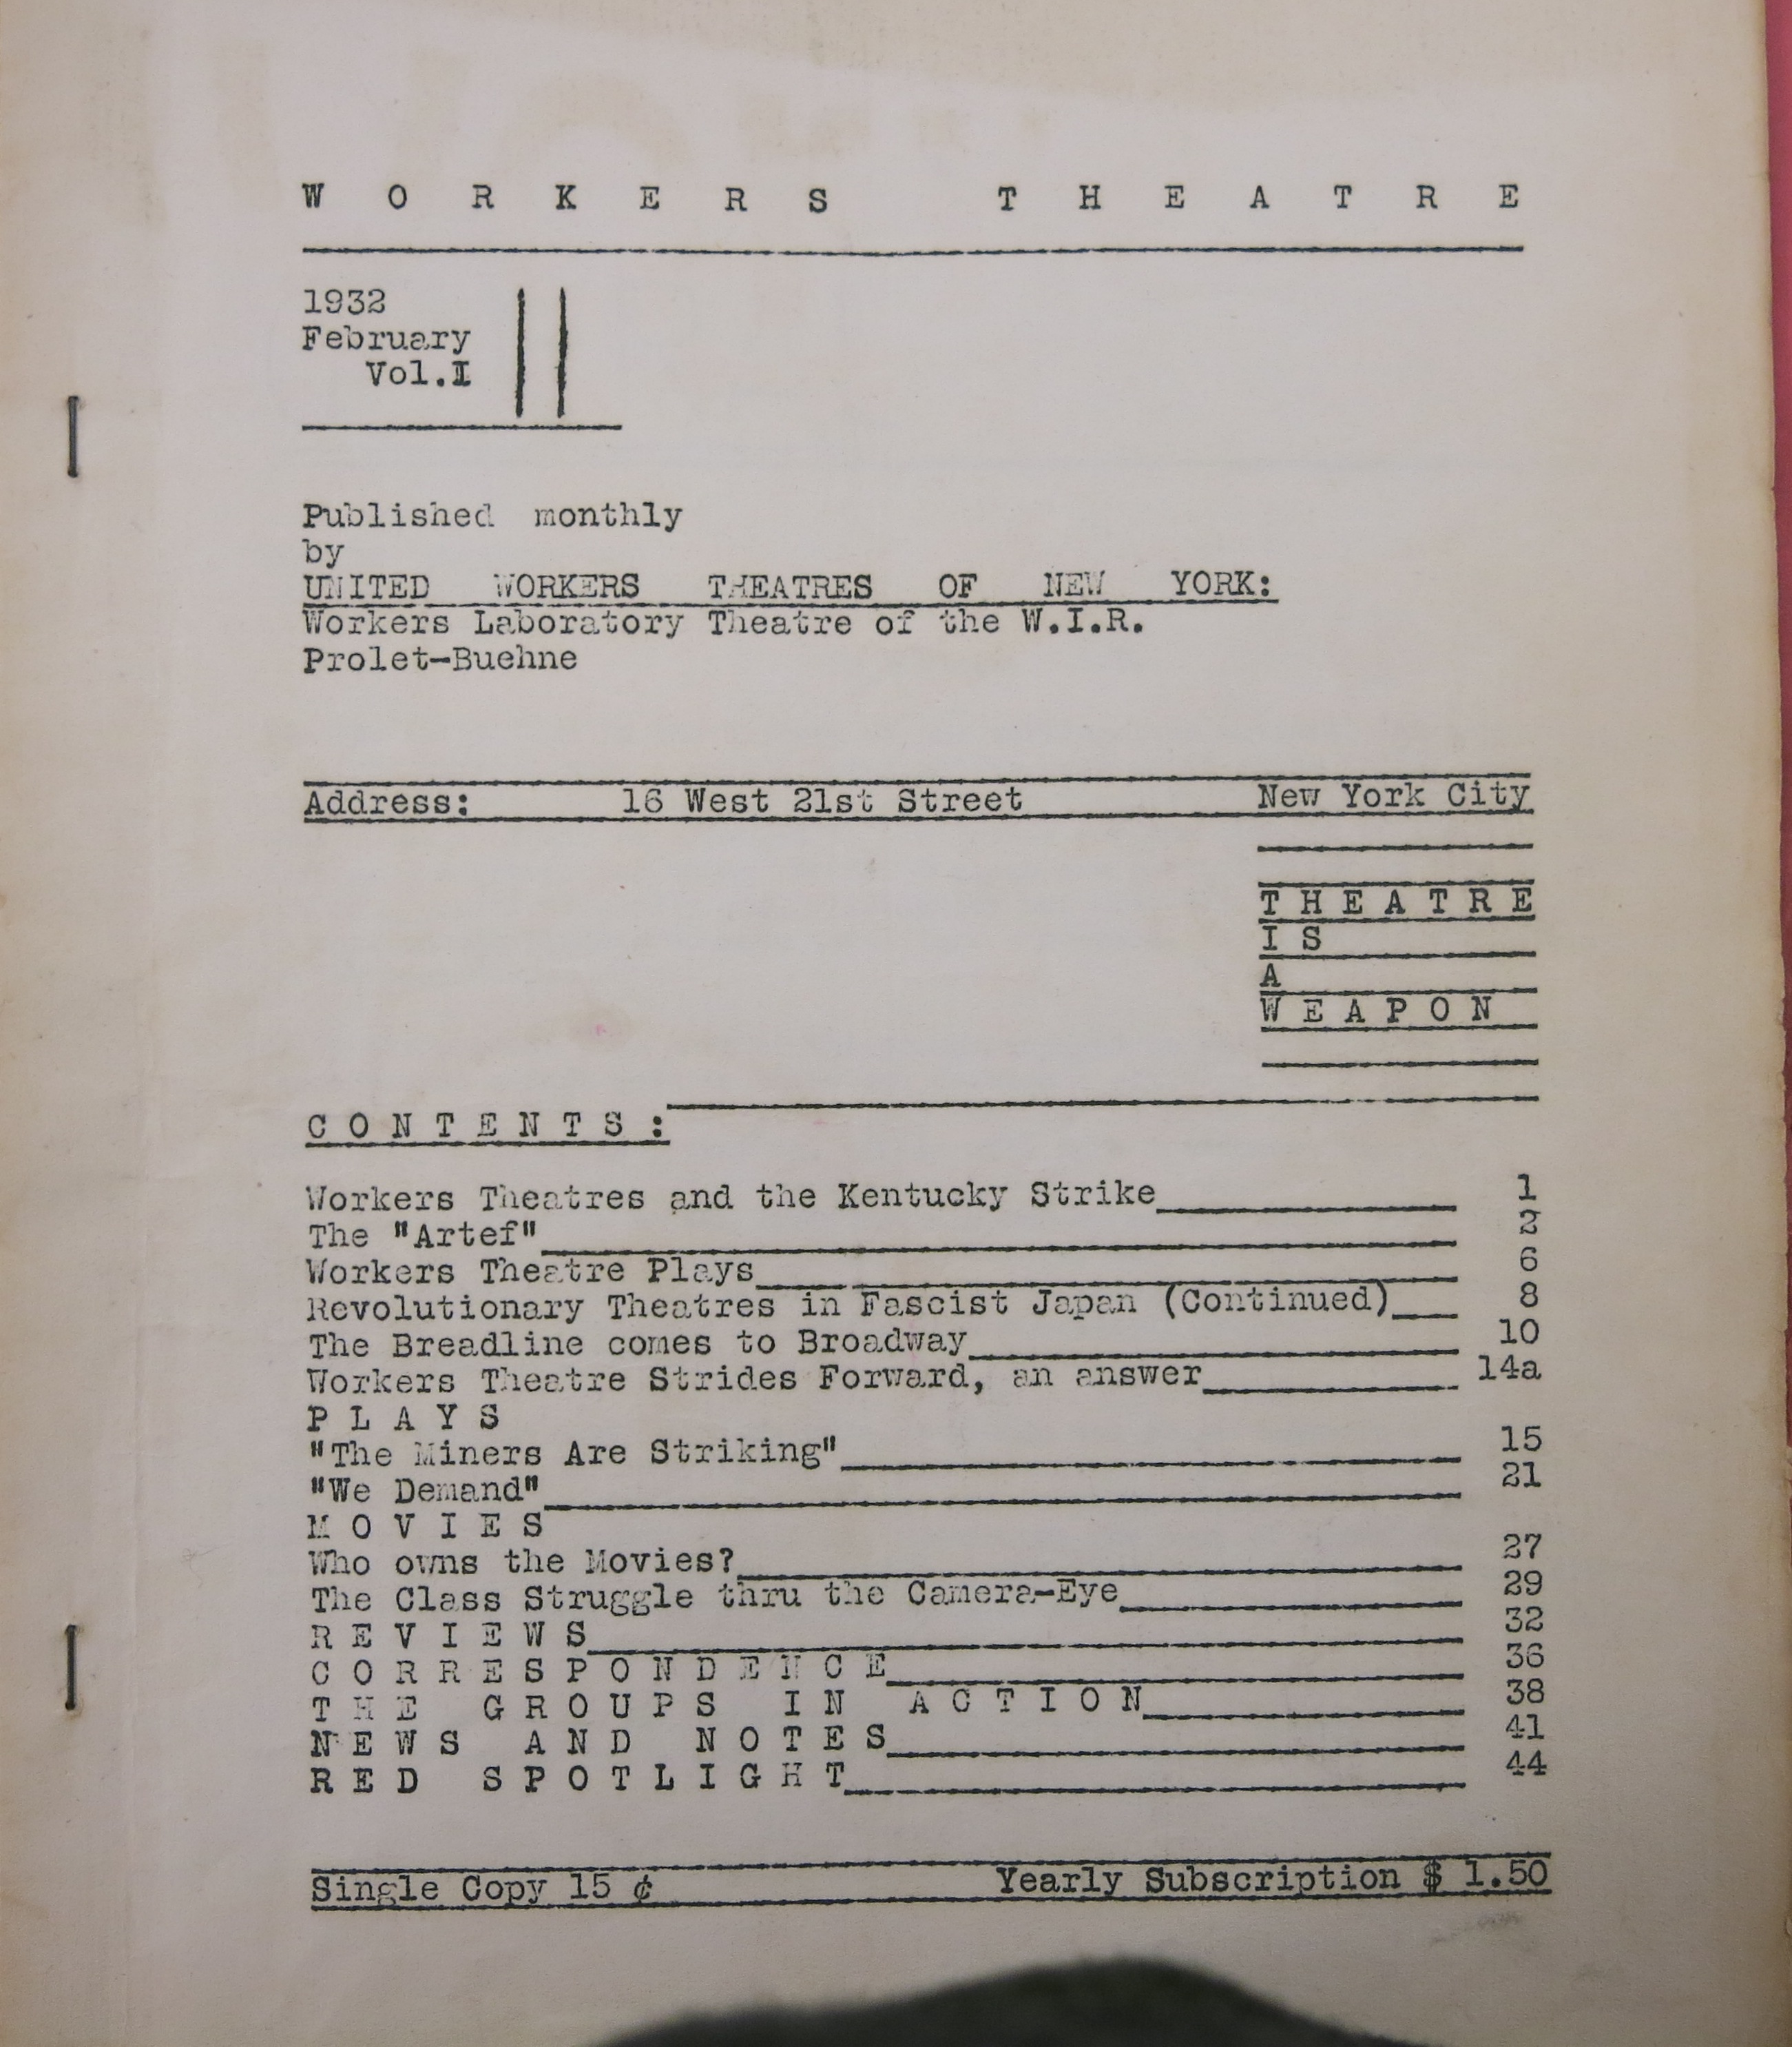

The cover of the first issue of Workers Theatre, published by the United Workers Theatres of New York, 1932.
[Source: L.W. Conolly Theatre Archives, McLaughlin Library, University of Guelph.]

